Sajeevan Arunthavaratnam 202220321

Assignment #1

- Provide Step by step guideline on how to create a project with Screenshot if possible

The command used to create a project is: gcloud projects create [project ID]

2. Provide Step by step guideline on how to setup default Zones and Regions with Screenshot if possible

The command used to change the default zone and regions is: gcloud config set compute/region northamerica-northeast1 to choose Montreal specifically.
3. Provide Step by step guideline on how to list all the projects in your GCP account with screenshots if possible

The command to list your projects is: gcloud projects list.

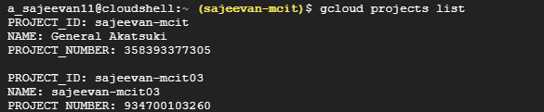

4. Provide Step by step guideline on how to list all the GCP regions and zones with Screenshot if possible
The command to list all the GCP regions and zones is: gcloud compute zones list and: gcloud compute regions list
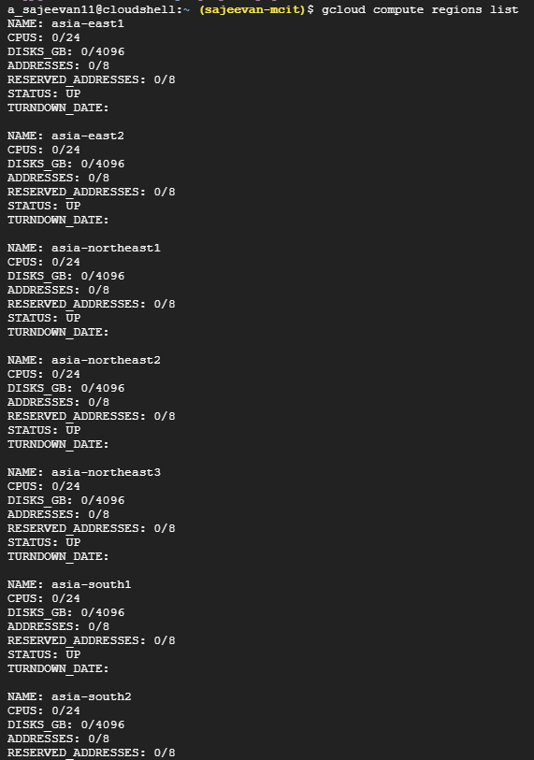
and for Zones
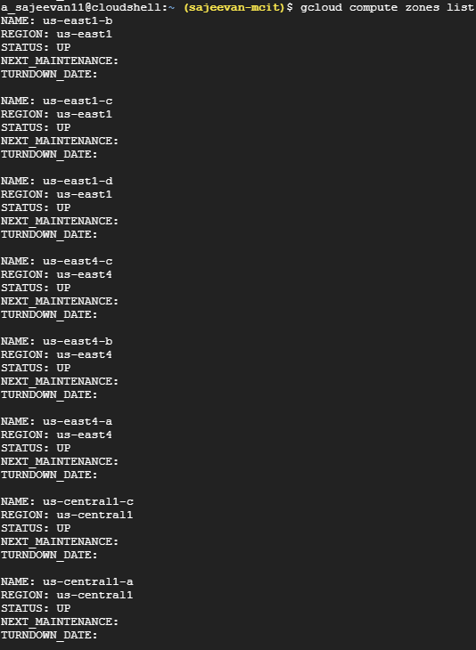

Creating buckets:
gcloud storage buckets create gs://BUCKET_NAME

Public access for Google Cloud Storage Bucket and Object​
gcloud storage objects update gs://BUCKET_NAME/OBJECT_NAME --add-acl-grant=entity=AllUsers,role=READER

to upload image/text into bucket

gcloud storage cp 'object' gs://'bucketname'

SQL Database – relational

gcloud sql connect myinstance --user=root

